

**Course Code:** CSE 320

**Course Title:** Computer networks lab

**Date of submission:** 01.10.2020

Name: Rashik Rahman

ID: 17201012

Sec: A2

IOT simulation using packet tracer. Here the goal was to do home automation that can be controlled from office. To do that I needed,

* IOT server
* Switch
* Laptop
* Home router
* Smart fan
* Smart lamp
* Smart door
* Smart garage door

The network address of the home network and office network are 192.168.0.0 and 192.168.2.0 respectively.

Let’s discuss about the setup. All the Smart devices are connected to home router using WIFI. The home router is connected to switch which is connected to an in-built home IOT server. The switch is also connected to the internet so that the residence can connect to the home from anywhere (here we connect to home network from office).

IOT server will keep state of all the connected devices and their credentials. Here’s some screenshot of the IOT server.

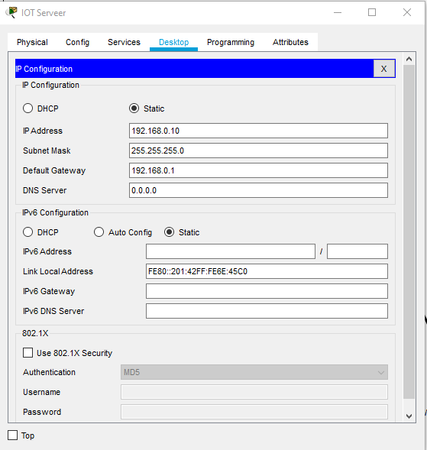

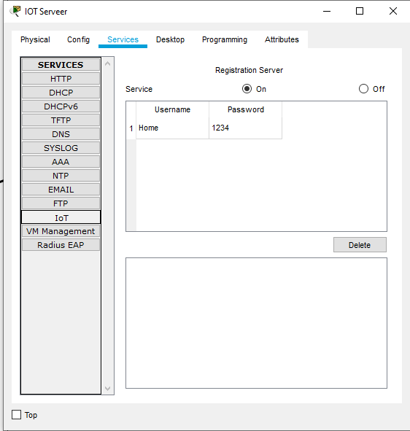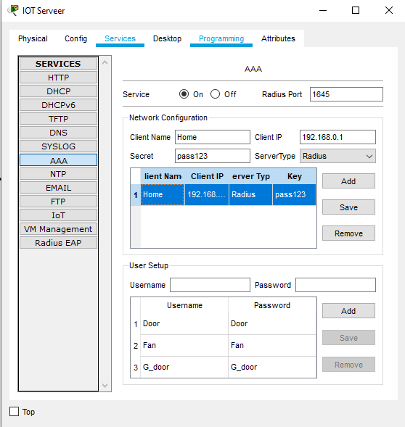

After the server I had to configure the home router. Router config looks like this

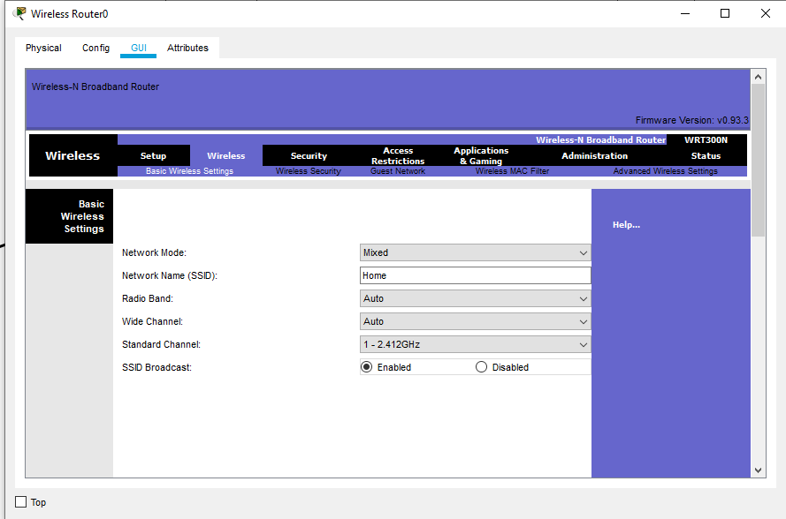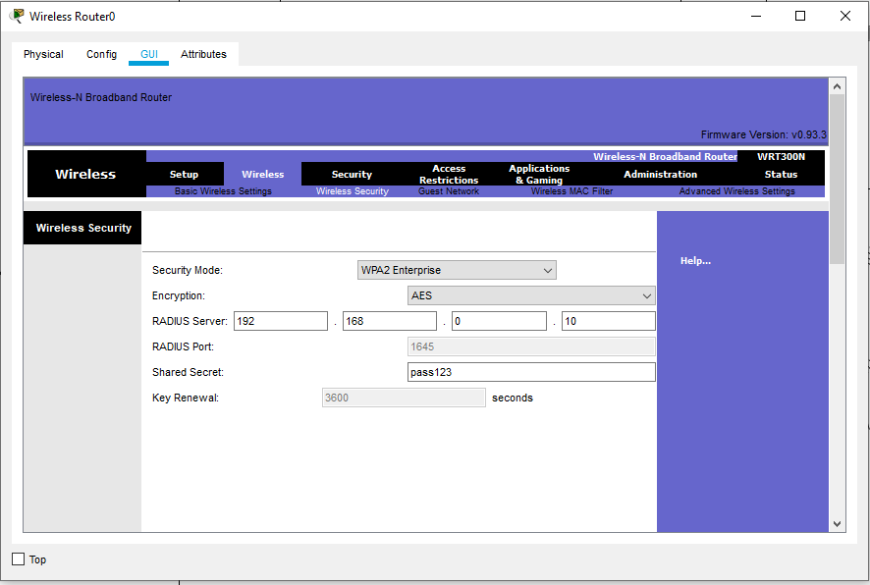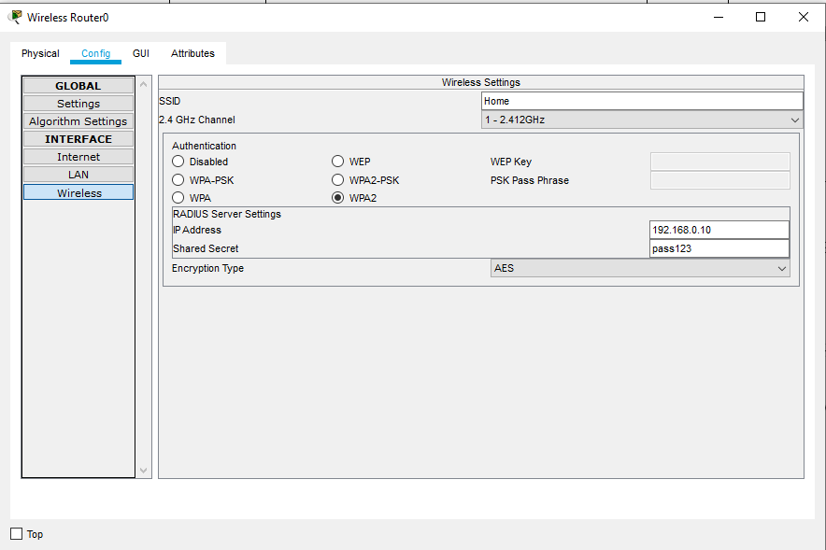

Now I had to configure the smart devices. To configure them first I have to enable the advanced settings. After that I setup the I/O config. Then in the config section first need to setup a remote server environment in the global setting then have to setup wireless connection of the smart devices by passing their credentials that was stored in IOT server.

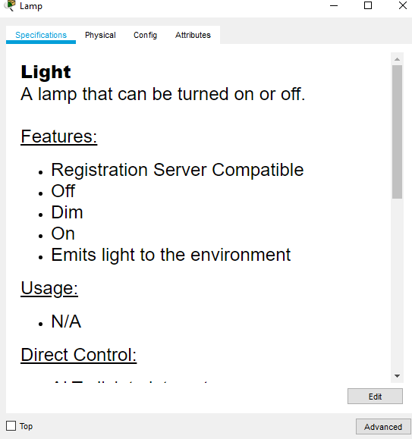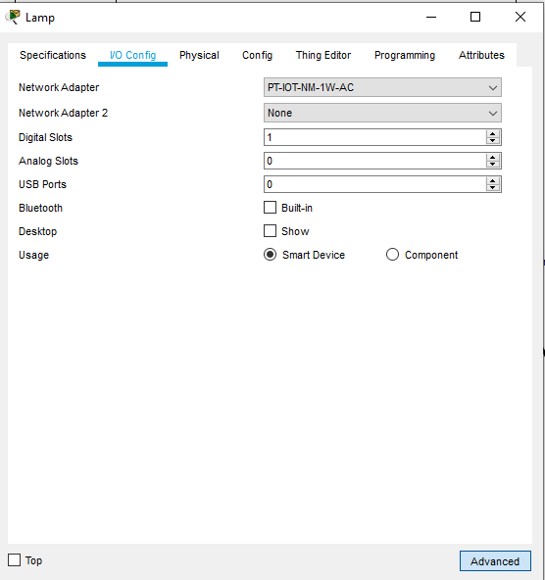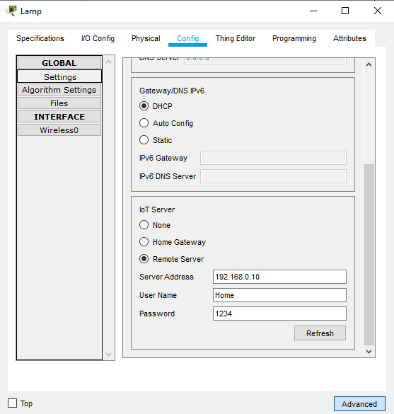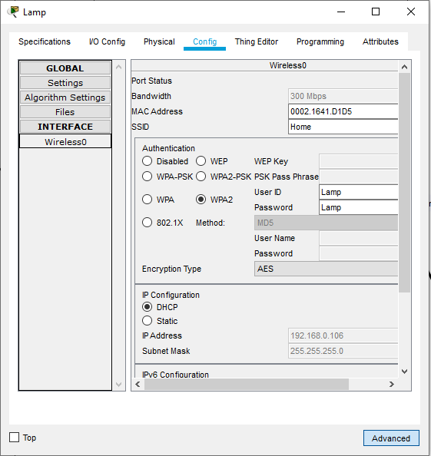

I repeated the same process for all the smart device. After that I had to setup the Internet router configs. Routing table is 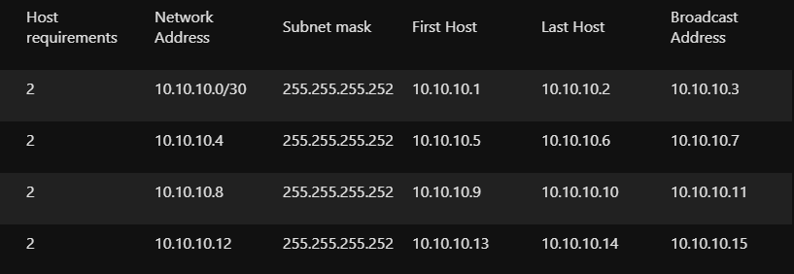

Router 0:

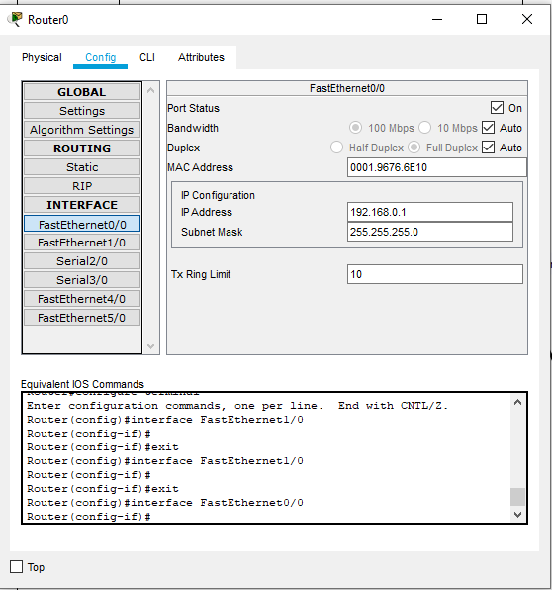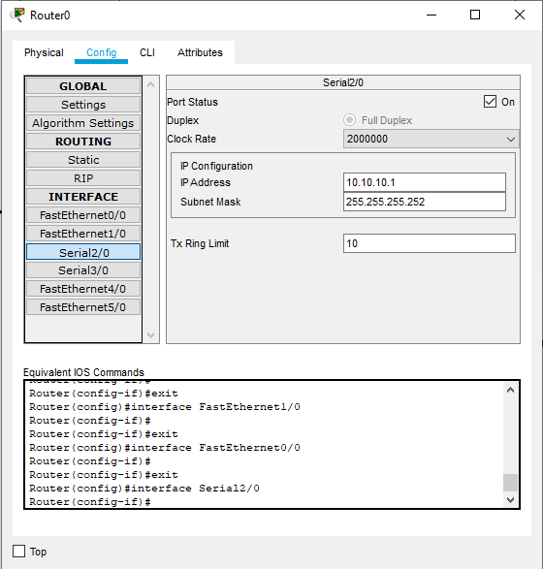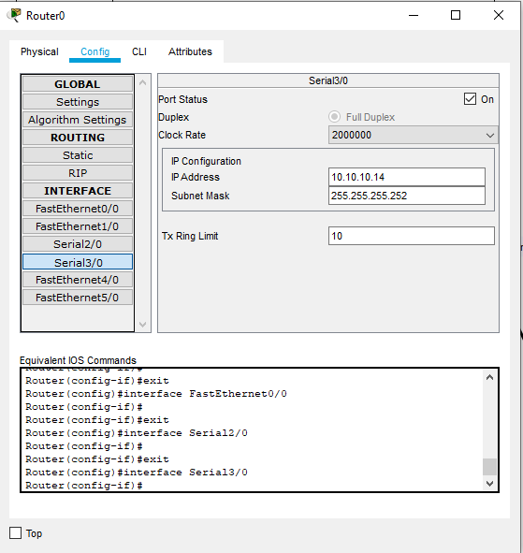

Router 2:

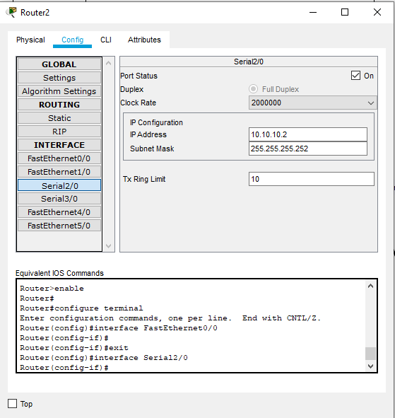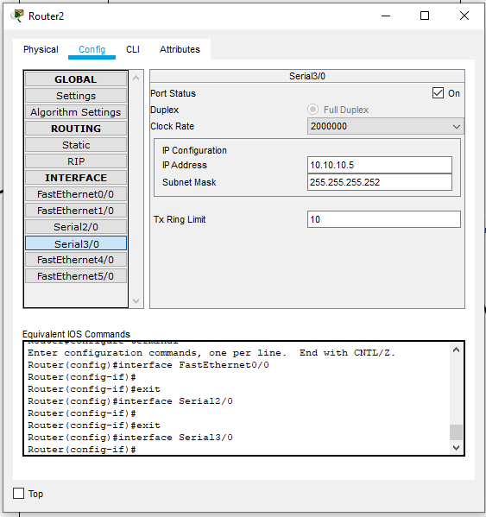

Router 3:

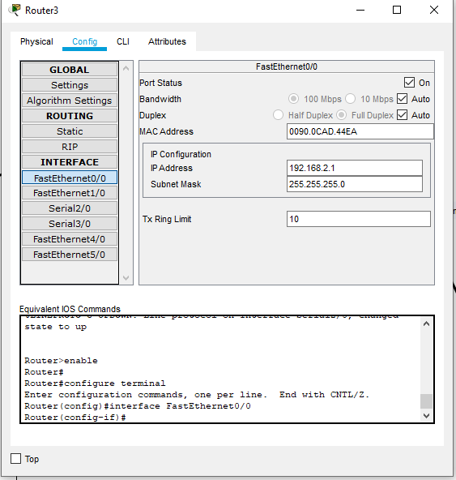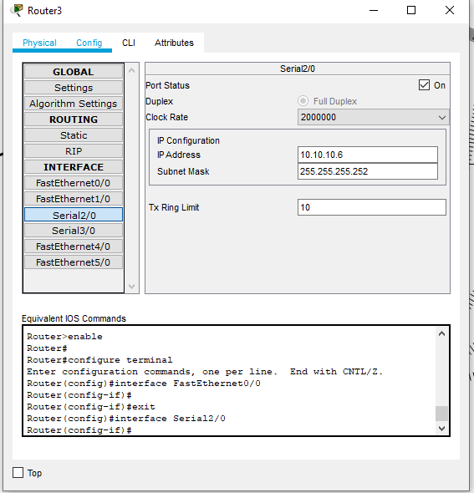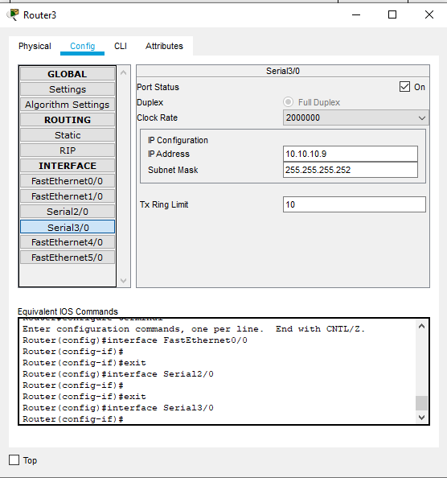

Router 1:

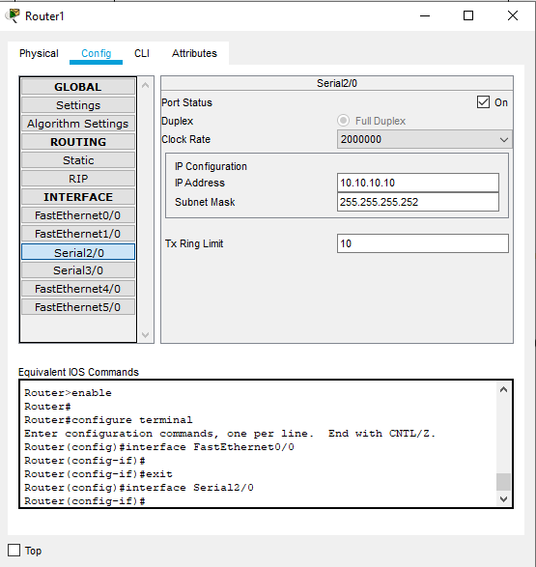 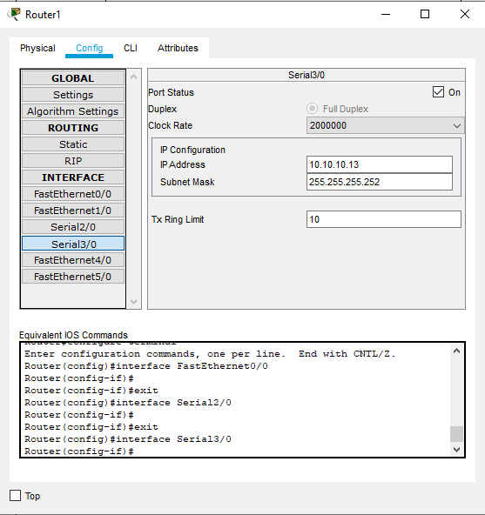

Office device :

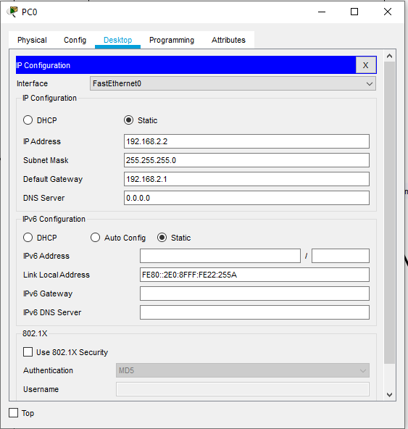

The routing was done by using CLI and VLSM router rip version 2.

Full design and use case:

